DATA STRUCTURES LAB EXPERIMENTS

SANSKRUTI SAMANT

USN: 2GI17EC113

DIV: B

# **EXPERIMENT 3 a:** Factorial Using Recursion Using C++.

* **PROBLEM STATEMENT**:

Write a C++ program to calculate the factorial of a given number using recursion.

* **ALGORITHM:**

Step 1: Start Step

2: Read number n.

Step 3: Call factorial(n)

Step 4: Print factorial f Step 5: Stop

▪ factorial (n):

Step 1: If n==0 then return 1

Step 2: Else: fact=n*factorial(n-1);

Step 3: return fact

* **PROGRAM CODE:**

#include<iostream>

using namespace std;

int factorial(int n);

int main()

{

int num;

cout<<"\nEnter the number:";

cin>>num;

cout<<"\nFactorial of entered number:"<<factorial(num);

return 0;

}

int factorial(int n)

{

int fact;

if(n==0)

return 1;

else

fact=n*factorial(n-1);

return fact;

}

* **PROGRAM OUTPUT:**

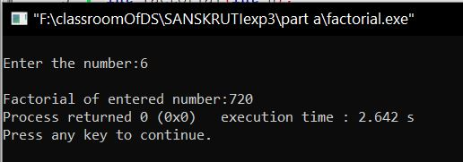

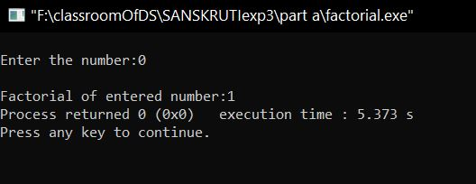

* **ANALYSIS (LIMITATIONS):**

Disadvantages of recursion:

* + Fairly slower than its iterative solution.
  + For each step we make a recursive call to a function. ...
  + May cause stack-overflow if the recursion goes too deep to solve the problem.
  + Difficult to debug and trace the values with each step of recursion.